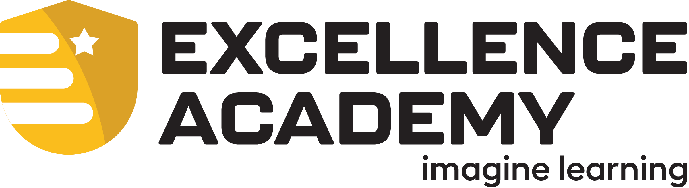
PARTNER SERVICES AGREEMENT
Supporting Student Success Through Strong Partnerships

CONTROLLED DOCUMENT — External Partner Use  Document ID: ILEA-PSA-2026-001  Version: 1.0  Effective Date: July 1, 2026  Review Cycle: Annual  Document Owner: ILEA | PARTNERSHIP INFORMATION  Partner Organization: {{Partner_Organization}}  Program Lead: {{Program_Lead_Name}}  Program Lead Email: {{Program_Lead_Email}}

Welcome to the Partnership
Welcome to Imagine Learning Excellence Academy (ILEA). We believe exceptional student outcomes are achieved through strong partnerships built on shared responsibility, clear communication, and operational excellence. This Agreement establishes the operational expectations between ILEA and the Partner Organization and serves as the foundation for our partnership.
Our Partnership Promise: Together, we are committed to providing students with an exceptional educational experience through shared responsibility, clear communication, and operational excellence.

Purpose
This Agreement defines operational responsibilities, establishes ILEA's academic authority, promotes consistent communication and accountability, and supports successful partnerships focused on student achievement. Detailed procedures are maintained in the ILEA Partner Resource Hub.
Our Partnership
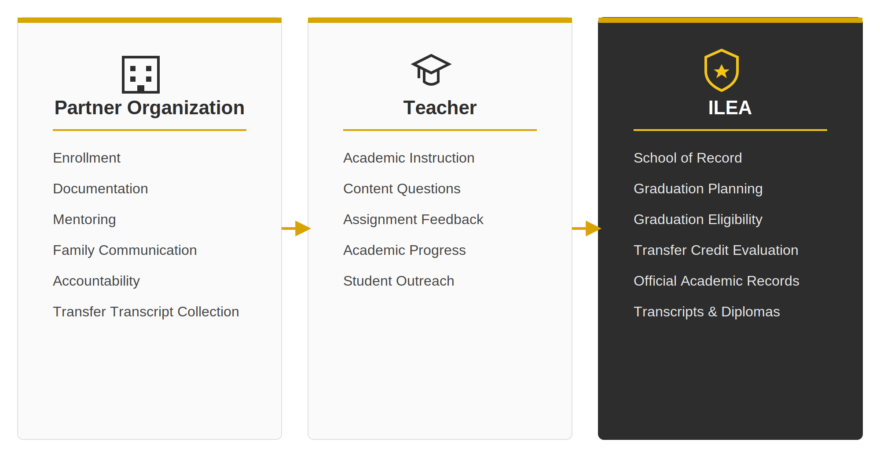
Partnership Commitments
Student Enrollment, Records & Information  Partner Organization will:  - Create student accounts and maintain accurate student, legal guardian, mentor, and emergency contact information within ILVP.  - Create legal guardian accounts and maintain current guardian information.  - Assign a mentor to every enrolled student.  - Enroll students into appropriate courses within ILVP, unless enrollment services have been purchased.  - Ensure the Enrollment Form is completed within 14 calendar days of course start/activation.  - Submit all required enrollment documentation within the same 14-day period.  - Maintain student records within ILVP and update promptly.  Operational Standards  - Two emergency contacts must be on file for student security purposes. The Partner Organization should notify ILEA within five (5) business days if emergency contact information changes.  - Required documentation: Enrollment Form, birth certificate, guardian ID/proof of guardianship, and any state-required documentation; ILVP is the official operational system of record.  - Students without completed documentation within 14 days may be administratively withdrawn.  - ILEA may communicate directly with students/guardians on academic matters, documentation, graduation, events, and services.  - Additional fees may be required, including but not limited to senior dues, notary services, rush orders, and shipping fees. Failure to pay may result in a hold placed on student account. | Partner  Initials
Academic Decision-Making Authority  Operational Standards  - ILEA is the accredited private school and official school of record.  ILEA retains sole authority over:  - Grades and grade changes; course completion status  - Transfer credit evaluation and application  - Graduation planning and eligibility  - Official academic records, transcripts, and diplomas  - Academic Integrity investigations and consequences  - NCAA reclassification requests  - Alumni status  Partner Organization:  Partner Organization may withdraw students but may not alter academic records, grades, graduation determinations, transcripts, diplomas, or alumni status.  Partner may not alter, reinterpret, override, or misrepresent official academic determinations. Only authorized ILEA staff issue official documents; transcripts are ordered through Parchment. | Partner  Initials
Student Mentoring & Family Partnership  Partner Organization will:  - Ensure mentors complete required ILEA mentor training.  - Serve as the primary contact for students/guardians except academic instruction and teacher communication.  - Serve as primary liaison between ILEA staff and the student/family for operational matters.  - Communicate regularly regarding participation, pacing, engagement, and accountability.  - Maintain regular communication with the assigned Academy Support Advisor.  - Recommend tutoring, teacher assistance, and academic support when appropriate. | Partner  Initials
Academic Integrity  Partner Organization will:  - Reinforce the ILEA Academic Integrity Policy.  - Ensure Proctorio is installed and used whenever required.  - Support ILEA Academic Integrity investigations.  - Cooperate in implementing required academic consequences.  Operational Standards  - Proctorio is required when designated by ILEA.  - ILEA retains sole authority over investigations and consequences.  - Consequences may include warnings, assignment/course failure, retakes, suspension, expulsion, and enrollment charges. | Partner  Initials
Course Completion Timeframes & Additional Enrollments  Partner Organization will:  - Monitor student progress, encourage students to remain on pace and support timely course completion.  Operational Standards  - Fall/Spring courses: 18-week completion. Summer courses: 8-week completion.  - Courses beyond the completion timeframe incur an additional enrollment charge, payable by the Partner Organization.  - Students who fail to complete coursework within the timeframe may be required to re-enroll. | Partner  Initials
Student Records, Transfer Credit & Graduation  Partner Organization will:  - Obtain official, signed, and dated transcripts.  - Submit required graduation documentation.  - Support students completing ILEA graduation plans.  - Consult with ILEA before academic decisions affecting graduation/transfer credit.  Operational Standards  - ILEA determines graduation plans, eligibility, and transfer credit acceptance.  - ILEA requires 22 credits to graduate; the final six (6.0) credits must be completed through ILEA.  - 60 consecutive inactive days restarts residency requirement.  - Transcripts are ordered through Parchment.  Dual Enrollment:  - Requires prior written ILEA approval; should not duplicate ILEA courses.  - Unapproved courses are not guaranteed to satisfy graduation requirements.  Advanced Placement:  - ILEA does not administer AP exams. Students are responsible for registration and materials. | Partner  Initials
NCAA (If Applicable)  Partner Organization will:  - Follow ILEA NCAA operational requirements.  - Consult ILEA before NCAA-related academic decisions.  - Support NCAA student engagement requirements.  Operational Standards  - NCAA requirements are separate from graduation requirements.  - The NCAA Eligibility Center determines eligibility; ILEA manages reclassification requests.  - Failure to meet ILEA NCAA requirements may affect NCAA review. | Partner  Initials
Student Support Services & Educational Placement  Operational Standards  - ILEA does not develop/administer IEPs or Section 504 Plans.  - Limited accommodations may be available but are not special education services.  - Partner determines whether ILEA is an appropriate educational placement.  - State requirements may include immunization or residency documentation. | Partner  Initials
Operational Resources & Ongoing Responsibilities  Partner Organization will:  - Review the ILEA Partner Resource Hub regularly.  - Remain informed of local and state-specific education laws and current operational guidance.  - Contact the Academy Support Advisor before decisions affecting students.  Operational Standards  - ILEA may update procedures/resources during the term.  - Material changes to this Agreement will be communicated.  - ILEA is not responsible for students’ internet activities. | Partner  Initials

Partner Certification
By signing this Agreement, the Partner Organization certifies that it has reviewed each section of this Agreement, understands the respective responsibilities of the Partner Organization, ILEA, and ILEA teachers, and agrees to operate in accordance with the expectations outlined herein. The Partner Organization further certifies that it will remain informed of current operational guidance published within the ILEA Partner Resource Hub and will contact its assigned Academy Support Advisor with questions regarding partnership expectations, operational procedures, or policy updates.

Partner Organization Signature Emergency Contacts
Authorized Representative: Primary Emergency Contact Name:
Title: Primary Contact Phone Number:
Signature: Secondary Emergency Contact Name:
Date: Secondary Contact Phone Number:
General Assistance: (888) 866-4989 • ilea@ilacademies.com | ilexcellenceacademy.com | Partner Resource Hub
Thank you for partnering with Imagine Learning Excellence Academy.
We look forward to supporting you and your students throughout a successful partnership.

