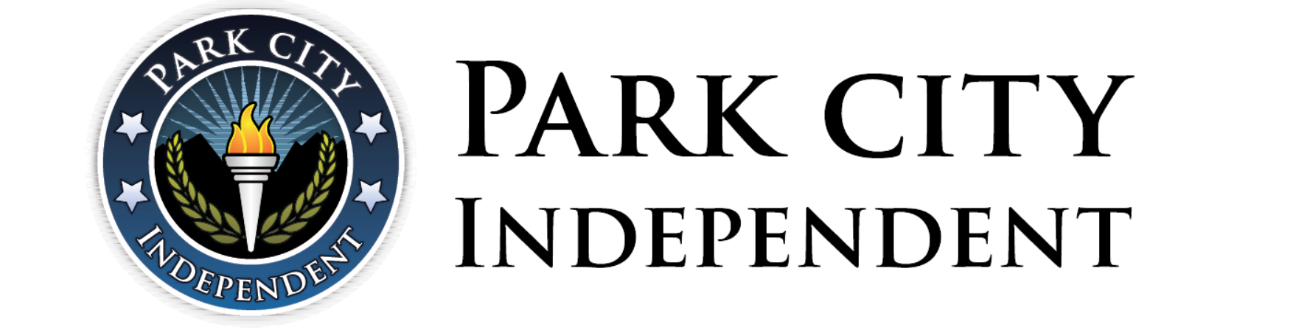
PARTNER SERVICES AGREEMENT
Supporting Student Success Through Strong Partnerships

CONTROLLED DOCUMENT — External Partner Use  Document ID: PCI-PSA-2026-001  Version: 1.0  Effective Date: July 1, 2026  Review Cycle: Annual  Document Owner: PCI | PARTNERSHIP INFORMATION  Partner Organization: {{Partner_Organization}}  Program Lead: {{Program_Lead_Name}}  Program Lead Email: {{Program_Lead_Email}}

Welcome to the Partnership
Welcome to Park City Independent (PCI). We believe exceptional student outcomes are achieved through strong partnerships built on shared responsibility, clear communication, and operational excellence. This Agreement establishes the operational expectations between PCI and the Partner Organization and serves as the foundation for our partnership.
Our Partnership Promise: Together, we are committed to providing students with an exceptional educational experience through shared responsibility, clear communication, and operational excellence.

Purpose
This Agreement defines operational responsibilities, establishes PCI's academic authority, promotes consistent communication and accountability, and supports successful partnerships focused on student achievement. Detailed procedures are maintained in the PCI Partner Resource Hub.
Our Partnership
  Partner Organization |   Teacher |   PCI
Enrollment  Documentation  Mentoring  Family Communication  Accountability  Transfer Transcript Collection | Academic Instruction  Content Questions  Assignment Feedback  Academic Progress  Student Outreach | School of Record  Graduation Planning  Graduation Eligibility  Transfer Credit Evaluation  Official Academic Records  Transcripts & Diplomas

Partnership Commitments
Student Enrollment, Records & Information  - Create student accounts and maintain accurate student, legal guardian, mentor, and emergency contact information within ILVP.  - Create legal guardian accounts and maintain current guardian information.  - Assign a mentor to every enrolled student.  - Enroll students into appropriate courses within ILVP, unless enrollment services have been purchased.  - Ensure the Enrollment Form is completed within 14 calendar days of course start/activation.  - Submit all required enrollment documentation within the same 14-day period.  - Maintain student records within ILVP and update promptly.  Operational Standards  - Two emergency contacts must be on file for student security purposes. The Partner Organization should notify PCI within five (5) business days if emergency contact information changes.  - Required documentation: Enrollment Form, birth certificate, guardian ID/proof of guardianship, and any state-required documentation; ILVP is the official operational system of record.  - Students without completed documentation within 14 days may be administratively withdrawn.  - PCI may communicate directly with students/guardians on academic matters, documentation, graduation, events, and services.  - Additional fees may be required, including but not limited to senior dues, notary services, rush orders, and shipping fees. Failure to pay may result in a hold placed on student account. | Partner  Initials
Academic Decision-Making Authority  Operational Standards  - PCI is the accredited private school and official school of record.  PCI retains sole authority over:  - Grades and grade changes; course completion status  - Transfer credit evaluation and application  - Graduation planning and eligibility  - Official academic records, transcripts, and diplomas  - Academic Integrity investigations and consequences  - Alumni Status  Partner Organization:  - Partner Organization may withdraw students but may not alter academic records, grades, graduation determinations, transcripts, diplomas, or alumni status.  - Partner may not alter, reinterpret, override, or misrepresent official academic determinations. Only authorized PCI staff issue official documents; transcripts are ordered through Parchment. | Partner  Initials
Student Mentoring & Family Partnership  Partner Organization will:  - Ensure mentors complete required PCI mentor training.  - Serve as the primary contact for students/guardians except academic instruction and teacher communication.  - Serve as primary liaison between PCI staff and the student/family for operational matters.  - Communicate regularly regarding participation, pacing, engagement, and accountability.  - Maintain regular communication with the assigned Academy Support Advisor.  - Recommend tutoring, teacher assistance, and academic support when appropriate. | Partner  Initials
Academic Integrity  Partner Organization will:  - Reinforce the PCI Academic Integrity Policy.  - Ensure Proctorio is installed and used whenever required.  - Support PCI Academic Integrity investigations.  - Cooperate in implementing required academic consequences.  Operational Standards  - Proctorio is required when designated by PCI.  - PCI retains sole authority over investigations and consequences.  - Consequences may include warnings, assignment/course failure, retakes, suspension, expulsion, and enrollment charges. | Partner  Initials
Course Completion Timeframes & Additional Enrollments  Partner Organization will:  - Monitor student progress.  - Encourage students to remain on pace.  - Support timely course completion.  Operational Standards  - Fall/Spring courses: 18-week completion. Summer courses: 8-week completion.  - Courses beyond the completion timeframe incur an additional enrollment charge, payable by the Partner Organization.  - Students who fail to complete coursework within the timeframe may be required to re-enroll. | Partner  Initials
Student Records, Transfer Credit & Graduation  Partner Organization will:  - Obtain official, signed, and dated transcripts.  - Submit required graduation documentation.  - Support students completing PCI graduation plans.  - Consult with PCI before academic decisions affecting graduation/transfer credit.  Operational Standards  - PCI determines graduation plans, eligibility, and transfer credit acceptance.  - PCI requires 22 credits to graduate; the final six (6.0) credits must be completed through PCI.  - 60 consecutive inactive days restarts residency requirement.  - Transcripts are ordered through Parchment.  Dual Enrollment:  - Requires prior written PCI approval; should not duplicate PCI courses.  - Unapproved courses are not guaranteed to satisfy graduation requirements. | Partner  Initials
Student Support Services & Educational Placement  Operational Standards  - PCI does not develop/administer IEPs or Section 504 Plans.  - Limited accommodations may be available but are not special education services.  - Partner determines whether PCI is an appropriate educational placement.  - State requirements may include immunization or residency documentation. | Partner  Initials
Operational Resources & Ongoing Responsibilities  Partner Organization will:  - Review the PCI Partner Resource Hub regularly.  - Remain informed of local and state-specific education laws and current operational guidance.  - Contact the Academy Support Advisor before decisions affecting students.  Operational Standards  - PCI may update procedures/resources during the term.  - Material changes to this Agreement will be communicated.  - PCI is not responsible for students’ internet activities. | Partner  Initials

Partner Certification
By signing this Agreement, the Partner Organization certifies that it has reviewed each section of this Agreement, understands the respective responsibilities of the Partner Organization, PCI, and PCI teachers, and agrees to operate in accordance with the expectations outlined herein. The Partner Organization further certifies that it will remain informed of current operational guidance published within the PCI Partner Resource Hub and will contact its assigned Academy Support Advisor with questions regarding partnership expectations, operational procedures, or policy updates.
Partner Organization Signature Emergency Contacts
Authorized Representative: Primary Emergency Contact Name:
Title: Primary Contact Phone Number:
Signature: Secondary Emergency Contact Name:
Date: Secondary Contact Phone Number:

General Assistance: (888) 866-4989 | PCI@ilacademies.com | www.parkcityindependent.com | Partner Resource Hub
Thank you for partnering with Park City Independent
We look forward to supporting you and your students throughout a successful partnership.

